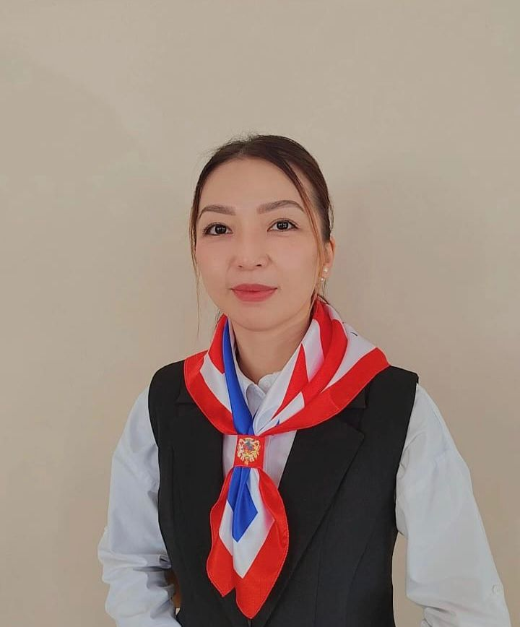
ДЖУМАНКУЛКЫЗЫ Нуриля,
№4 Балжан Бөлтірікова атындағы мектеп-лицейінің ағылшын тілі пәні мұғалімі.
Жамбыл облысы, Қордай ауданы

HEROES OF KAZAKHSTAN

Learning objectives | 6. 4. 2. 1 understand special information in simple, short texts within a number of general and educational topics without the help of a teacher;  6.5.3.1 write with some support about personal feelings and opinion on a limited range of familiar general and curricular topics.
Lesson objectives  (assessment criteria) | Learners will be able to:  - Understand short and simple texts related to general and educational topic about hero of Kazakhstan;  - Identify special or important information (e.g., names, dates, feelings) in these texts;  - Write short sentences or a short paragraph with some support about their personal feelings or opinions on a familiar topic (e.g., school subject, favorite activity).
Instilling values of the program “Adal Azamat” | - Independence and patriotism

Stages/  Time | Teachers actions | Students actions | Assessment | Resources
Beginning  2 min  5 min  6 min | Organization moment  1.Greeting.  - Hello class!  - “How are you today?” (Students reply: “I’m fine, thank you!” or other feelings.)  - “What day is it today?” (Students respond: “It’s Monday!”)  • “What’s the weather like today?” (Students answer: “It’s sunny!”)  2. Warm up: “Name 5”. Purpose: Activate prior knowledge, build vocabulary, and get students thinking quickly. How to play:  • Say or display a category.  • Students have 30–60 seconds to name 5 things that fit into that category.  • They can write share with a partner, or say them out loud.  • Keep it fast and fun — move to the next category quickly!  3 Checking the previous lesson:  Wordwall task:  Read and check the forming sentences in the Present simple Questions. | Ss greet their teacher and answer the questions  Students name 5 words  Learners read the question sentences and identify correct or incorrect of forming questions | Teacher evaluate pupils with phrases like:  “Good job!  Well done!”  Formative Assessment   | Slide 1  Wordwall  https://wordwall.net/ru/resource/14300780  Wordwall  https://wordwall.net/ru/resource/99727525
Middle  10 min  5 min | Pre-listening : "Guess the Hero!"(I)  • Look at the photos and try to guess who the hero is based on the descriptions.  • Write the name of the hero if you know it. If not, write "?".  • Be ready to discuss your guesses with a partner.  1 A great Kazakh poet and philosopher from the 19th century.  2. A brave Kazakh sniper women who fought in World War II.  3. The first Kazakh astronaut to go to space.  The people are:  1Aliya Moldagulova – a young sniper and war hero from World War II.  2Abai Kunanbayev – a poet, thinker, and cultural leader from the 1800s.  3Toktar Aubakirov – the first Kazakh astronaut, a pilot and engineer.  Then answer the questions:  - Who are the people?  - What do they have in common?  - Do you think this person is a hero?  - What qualities make someone a hero? Characteristics, abilities  - Would you like to be a hero? Why or why not?  - What do you think is the theme of our lesson?  (To activate students' vocabulary and speaking skills related to household chores before listening.)  While listening (W)  Let’s listen and read the text and check your answers.  Teacher asks:  -What the text is about?  New words:  Hero — a person who is brave and helps others.  Sniper- |ˈsnaɪpə(r)| снайпер  Poet - |ˈpəʊɪt| поэт  Thinker - |ˈθɪŋkə| мыслитель  Musician - |mjuːˈzɪʃ(ə)n|музыкант композитор  Astronaut — |ˈæstrənɔːt| ғарышкер  Engineer -|endʒɪˈnɪə| инженер | Learners look at the pictures and share their ideas  Ss guess the Hero and answer the questions. Then discuss about it  Values of the program“Adal Azamat” – Independence and patriotism by showing what it means to love and serve your country with honor, courage, and dedication to its freedom and future.  Learners read the given pictures on the board and guess the topic and share with their ideas.  Ss listen to the text and answer the questions  Ss learn new words | Descriptor:  - identify names of three Kazakh national heroes  - answer the questions and discuss  Criteria:  -The student correctly identifies each individual.  -The student explains how each person represents patriotism and/or independence.  FA: 2p | Flashcards  Slide 4  Video
2 min  10 min | Post-listening (P )  Matching. Read the text again. Write the names of jobs for each person.  Group Speaking  Group Activity: "Be the Hero!" – Role Play & Hero Booth  Objective:  1)Students will work in groups to "become" a Kazakh hero by preparing a short role play or live museum booth. | Learners identify the right answers and match  Learners work in groups to prepare a short role play or poster | Descriptor:  - read the text quietly on their own.  - find the correct answer  FA: 2 p | Student’s worksheet  Slide  poster
 | 2)They will act, speak, or present as if they are the hero and tell the class about their life and achievements.  3)Each group chooses (or is assigned) one of the following Kazakh heroes  4) Make a small poster or sign with your hero’s name |  |  | Poster
3 min | Reflection. Exit ticket  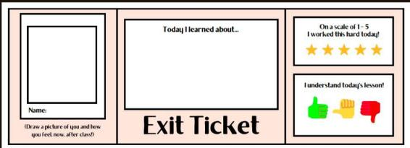  Assessment Map | Learners complete the ticket and write what they understood on the lesson. |  | Ticket cards
End  2 min | Homework: Write a short paragraph about “How I help at home.”  Saying good-bye | Ss use their stickers to show their knowledge according to the lesson

